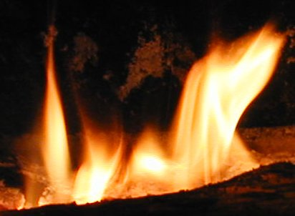

FANNING THE FLAMES

Inside this issue
River Rescue ………..……….1
Door Stops 2
Yuppie 911 ………………….3
Making It Manditory.………….4
Eye Spy 5
HAP ………………… …………6

Firefighter’s Newsletter

January, 2010
Volume 3, Issue 1
Old New, Big and Small 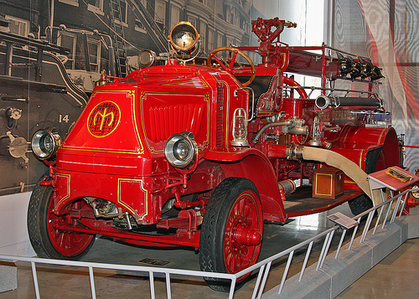
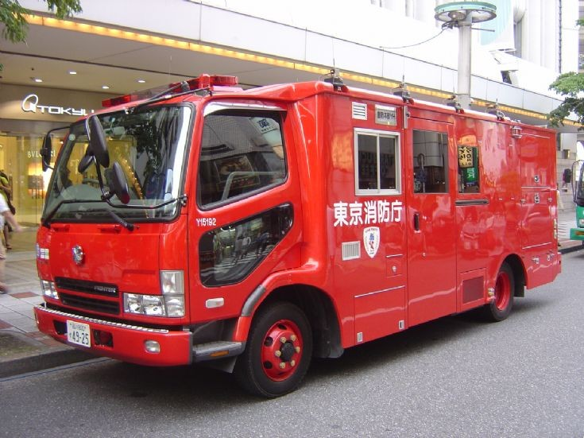
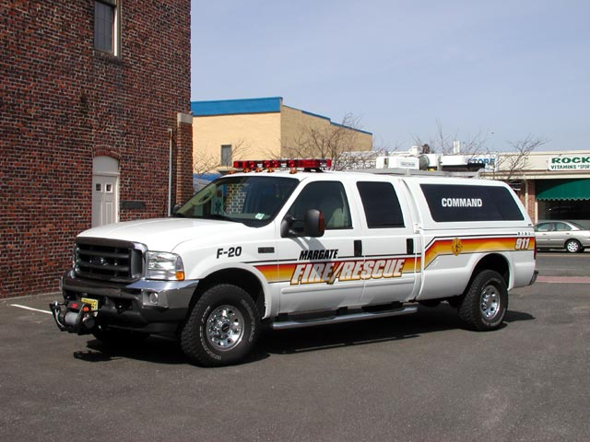
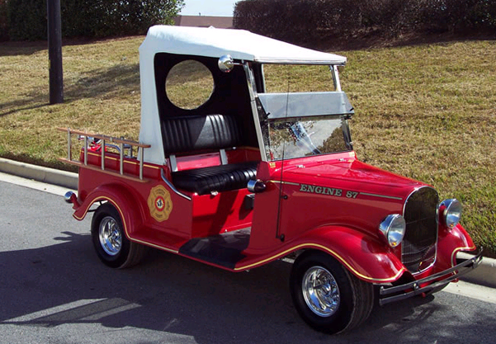

2 Volunteer Firefighters Rescued
From Virginia River
By Lerone Graham
The Roanoke Times
ROCKBRIDGE COUNY, Va. — Several crews were dispatched to Rockbridge County on Sunday night to rescue two Albermarle County volunteer firefighters left stranded after their canoe capsized.
The firefighters, a man and a woman in their 20s, were canoeing the James River for pleasure when they entered swift water and the canoe became wedged between two rocks, said Robert Foresman, emergency management coordinator with Rockbridge County.
Foresman said the two attempted to free the canoe, at which point it filled with water and sank.
He said they were able to get their belongings out and cling to a rock. While stranded, one of the firefighters called 911 from a cellphone.
Authorities received the call about 6 p.m. Crews from the Virginia State Police, Glasgow Fire Department, Glasgow Rescue Squad, Rockbridge County Emergency Management, Rockbridge County Sheriff's Office and the Buena Vista swiftwater rescue team responded.
The canoeists were out of the water by about 8:30 p.m. They were cold, but suffered no injuries.

Door Stops, Could Be Your Lifesaver
We have all been taught that keeping your egress free is one of the most important parts of making an entrance into a rescue or fire scene. The big question is, what is the best way to keep a door open?

There are a number of commercial and homemade products that can get the job done for you and your crew. Let’s take a look at a few of these high tech and low tech devices and then you can decide which one is the best for you.


The oldest and most low tech of all door stops is the tried and true wooden wedge. This is a simple wooden chock that wedges the door open or part way open. They are often homemade or “acquired” while doing fire inspections on public buildings. They can be carried in a pocket or in a helmet band. The biggest drawback to any wedge style chock is that it can be kick out of place or knocked out of place by boots or hoses. Every time the door is opened the wedge must be reset.

Wood isn’t the only material that is used for door wedges. There are a number of commercial wedges made of polymers and other top secret compounds. The bottom line is that they are still just a wedge. They are promoted as a wedge that will not split. Wood tends to dry out in the heat of a fire and can split after a time. These polymer wedges will not split even after many uses.

An example of a high tech version of the old wedge is the Wedge It. This wedge can be used under the door, over the door and in the hinge. The company that builds this product has included Velcro to make it a part of your accountability system.

Let’s put this wedge in its proper place. It is just a fancy door wedge, nothing more nothing less. I personally would not use this as a part of my accountability system. How often have you had to hunt around after a fire for your knife or tool, because one of the other firefighters stuck it in their pocket thinking it belonged to them? Well if your crew is like the one I am on, too many times to use this as an accountability device.


Magnetic chocks are placed over the striker plate on the door frame in order to stop the door from completely closing. This works well to keep the door from latching, however if you are intending to keep the door as a visible exit for rescue or firefighters, this is not your device. The door is still able to close, it just won’t latch.
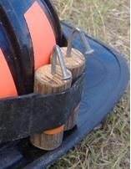
I have just built a set of Cherry Bombers for my kit. These items are homemade and simple to use. They are named after the fireworks due to their shape. These were created by Wayne Tolzman of the Tampa Fire Department in Tampa Florida. The advantages to hinge stops over door stops is that they stay in place no matter how often the door is opened or closed. It doesn’t get in the way or get dislodged by firefighting activities. You will be amazed how a piece of one and a half inch dowel and a large nail will get the job done.

The only critique that I have found about this system is drying and splitting, but they are easily and cheaply replaced.

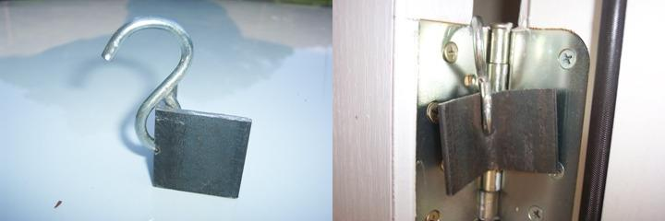
If you have tools to work with metal you can create a hinge stop that will never crack in the heat. They are heavy and bulky to carry but they are very effective. For this hinge stop you need a piece of angle iron and an S hook. It is recommended that you paint them with a bright florescent paint so that they will be visible when doing mop up.

What ever you use I would suggest that it be something inexpensive and easy to use. The chances of losing or forgetting you chock behind is quite high. I like the hinge stops due to the fact that they will not be kicked out or bind on the hose.

Get them, build them or buy them, but have them handy and use them. They could save a life and it might be yours.

Responders fear misuse of 'Yuppie 911' GPS beacons
By Tracie Cone
The Associated Press

FRESNO, Calif. — Last month two men and their teenage sons tackled one of the world's most unforgiving summertime hikes: the Grand Canyon's parched and searing Royal Arch Loop. Along with bedrolls and freeze-dried food, the inexperienced backpackers carried a personal locator beacon — just in case.
In the span of three days, the group pushed the panic button three times, mobilizing helicopters for dangerous, lifesaving rescues inside the steep canyon walls.
What was that emergency? The water they had found to quench their thirst "tasted salty."
If they had not been toting the device that works like Onstar for hikers, "we would have never attempted this hike," one of them said after the third rescue crew forced them to board their chopper. It's a growing problem facing the men and women who risk their lives when they believe others are in danger of losing theirs.
Technology has made calling for help instantaneous even in the most remote places. Because would-be adventurers can send GPS coordinates to rescuers with the touch of a button, some are exploring terrain they do not have the experience, knowledge or endurance to tackle.
Rescue officials are deciding whether to start keeping statistics on the problem, but the incidents have become so frequent that the head of California's Search and Rescue operation has a name for the devices: Yuppie 911.
"Now you can go into the back country and take a risk you might not normally have taken," says Matt Scharper, who coordinates a rescue every day in a state with wilderness so rugged even crashed planes can take decades to find. "With the Yuppie 911, you send a message to a satellite and the government pulls your butt out of something you shouldn't have been in in the first place."
From the Sierra to the Cascades, Rockies and beyond, hikers are arming themselves with increasingly affordable technology intended to get them out of life-threatening situations.
While daring rescues are one result, very often the beacons go off unintentionally when the button is pushed in someone's backpack, or they are activated unnecessarily, as in the case of a woman who was frightened by a thunderstorm.
"There's controversy over these devices in the first place because it removes the self sufficiency that's required in the back country," Scharper says. "But we are a society of services, and every service you need you can get by calling."
The sheriff's office in San Bernardino County, the largest in the nation and home to part of the unforgiving Death Valley, hopes to reduce false alarms. So it is studying under what circumstances hikers activate the devices.
"In the past, people who got in trouble self-rescued; they got on their hands and knees and crawled out," says John Amrhein, the county's emergency coordinator. "We saw the increase in non-emergencies with cell phones: people called saying 'I'm cold and damp. Come get me out.' These take it to another level."
Personal locator beacons, which send distress signals to government satellites, became available in the early 1980s, but at a price exceeding $1,200. They have been legal for the public to use since 2003, and in the last year the price has fallen to less than $100 for devices that send alerts to a company, which then calls local law enforcement.
When rescue beacons tempt inexperienced hikers to attempt trails beyond their abilities, that can translate into unnecessary expense and a risk of lives.
Last year, the beacon for a hiker on the Pacific Crest Trail triggered accidentally in his backpack, sending helicopters scrambling. Recently, a couple from New Bruswick, British Columbia activated their beacon when they climbed a steep trail and could not get back down. A helicopter lowered them 200 feet to secure footing.
In September, a hiker from Placer County was panning for gold in New York Canyon when he became dehydrated and used his rescue beacon to call for help.
With darkness setting in on the same day, Mono County sheriff's deputies asked the National Guard for a high-altitude helicopter and a hoist for a treacherous rescue of two beacon-equipped hikers stranded at Convict Lake. The next day they hiked out on foot.
When eight climbers ran into trouble last winter during a summit attempt of Mt. Hood in Oregon, they called for help after becoming stranded on a glacier in a snowstorm.
"The question is, would they have decided to go on the trip knowing the weather was going bad if they had not been able to take the beacons," asks Rocky Henderson of Portland Mountain Rescue. "We are now entering the Twilight Zone of someone else's intentions."
The Grand Canyon's Royal Arch loop, the National Park Service warns, "has a million ways to get into serious trouble" for those lacking skill and good judgment. One evening the fathers-and-sons team activated their beacon when they ran out of water.
Rescuers, who did not know the nature of the call, could not launch the helicopter until morning. When the rescuers arrived, the group had found a stream and declined help.
That night, they activated the emergency beacon again. This time the Arizona Department of Public Safety helicopter, which has night vision capabilities, launched into emergency mode.
When rescuers found them, the hikers were worried they might become dehydrated because the water they found tasted salty. They declined an evacuation, and the crew left water.
The following morning the group called for help again. This time, according to a park service report, rescuers took them out and cited the leader for "creating a hazardous condition" for the rescue teams.

The Art of Making it Mandatory
By Jason Zigmont
Anytime a volunteer department makes something 'mandatory' there is usually an outcry from the members along the lines of, "I joined the volunteer department, not the mandatory department." Unfortunately, with tough times and changing regulatory requirements, sometimes there is no choice to make certain drills, events, calls, or time mandatory. We have all gone through these battles before and many of us remember the nightmares of making people shave their beards due to OSHA mandates, and it is always painful but necessary. Mandating anything to a volunteer department is an art, but there are things you can do to make it easier.
It is easiest to mandate any requirements before a member joins. If a member knows in advance what is expected of them, they can then make an educated decision whether they have enough time to volunteer or not. While it is true that this may scare away some potential members, it is better that they know up front rather than have you springing the requirements on them after they have already committed a fixed amount of time to the department. One department I visited assigns each new member one Bingo night a month. The member then knows that they are responsible for the Bingo on the second Tuesday of the month and can plan accordingly. They also know that they are only responsible for the second Tuesday Bingo, and can choose to help on the other Bingos or not.
Mandating anything for existing members is going to be difficult but does not have to divide your department if it is fair for everyone and agreed upon. I know how hard it is to get agreement in a volunteer department and I know we have all beaten our own proverbial dead horses but if someone in power arbitrarily makes something mandatory then there is guaranteed to be trouble. There will be members who think everything should be mandatory and those who think nothing should be mandatory, but compromise is key. Neither group will be 100 percent happy, but a compromise may be the best chance you have of keeping the department from fighting non-stop about what is mandatory and what is not.
Only mission critical operations should be mandatory, and even then members' time must to be taken into account. In the previous example, if Bingo events are the department's primary source of income and pay for the building and fire apparatus, then they are definitely mission critical in addition to core firefighting duties. OSHA and other State or Federal agencies will most likely decide for you which drills are mandatory but the total number may be up for discussion. Responding to calls is at the core of why volunteer fire departments exist but it is not reasonable to expect your members to respond to every call. An alternative is setting a minimum percentage of calls during time when members are available. For example, if they work days, they may have to respond to 35 percent of all calls from 1800 to 0600 hours.
Once your department has decided what is mandatory, the next task is to decide what the members receive for meeting the minimum and what they lose for not meeting their requirements. Members should have to meet all of the mandatory requirements to qualify for any LOSAP or other incentive programs. If a member does not meet the mandatory requirements, they may have to be placed on probation or administrative leave until they meet the minimums. The key there is that the member has to have a chance to improve rather than just being summarily excommunicated from the department whenever they miss a drill or other mandatory event.
In order to be fair, everyone has to be held to exactly the same standards, no matter who they are. That means if the Chief's daughter does not meet the minimums then she is put on probation the same as the guy no one likes. Favoritism has destroyed many departments and when mandatory requirements are involved the effects of favoritism are multiplied. Mandatory programs have to be designed for the entire department and every member, not just to make members quit or get rid of 'problem' members. The first time someone is treated differently the entire program is destroyed.
In the end modern volunteer fire departments may have no choice but to make components mandatory. The challenge is making them fair for everyone and only requiring the absolute minimum. With a bit of planning and negotiating the needs of your department can be balanced with those of your members for a better department overall.

Eye Spy
We all are called upon to search dangerous environments. Wouldn’t it be great to have a device that could go into small hard to reach areas and send video back to the command station? This might just be the item. If you have the budget.
The Recon Scout® Rescue is a miniature, mobile reconnaissance device that will add greater safety and speed to your search and rescue and hazmat operations. Armed with this throwable, tetherable device first responders can quickly conduct initial reconnaissance within confined or dangerous spaces by directing the Rescue device to move through the environment and transmit live video of the scene to front line personnel and commanders. The performance characteristics of the Recon Scout Rescue make it ideally suited to this task:
- The Recon Scout Rescue is just seven inches long and weighs just one pound, making it extremely easy to carry and throw.
- Deploying the Rescue takes less than 15 seconds and requires no special training.
- The device is equipped with sophisticated infrared optical systems that can see in complete darkness and automatically turn on when the ambient light is low.
- The Rescue transmits clear, crisp video through walls and debris up to 100 feet to a handheld Operator Control Unit (OCU) or up to 1,000 feet to a Command Monitoring Station.
- The device can withstand throws of 120 feet and it can be tossed through windows or doors, over walls, or down a flight of stairs.
- It can also be dropped down a vertical shaft or into a void using a provided tether.
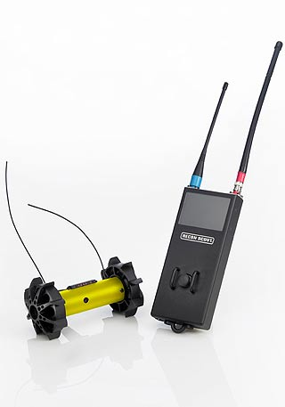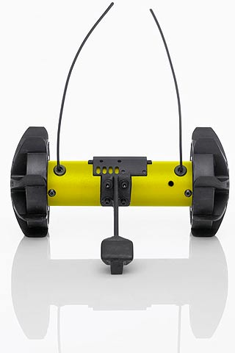
The Recon Scout Rescue is sold as a package with the ReconRobotics Command Monitoring Station, which allows your mobile command post or rescue unit to receive live video from the device. The Rescue may be specified in either of two operating frequencies, allowing you to use two robots in the same environment at the same time.
If you are interested in this product and would like to set up a demo call Katie Sisco at 1-866-697-6267 or check out their website at www.recon-scout.com.



Buch Air



Happy New Year


Page Two Brought To You By:



POTM
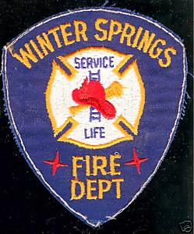
Which is it winter or spring?

Everyone Goes Home®
First 8 of the 16 Firefighter Life Safety Initiatives
- Define and advocate the need for a cultural change within the fire service relating to safety; incorporating leadership, management, supervision, accountability and personal responsibility.
- Enhance the personal and organizational accountability for health and safety throughout the fire service.
- Focus greater attention on the integration of risk management with incident management at all levels, including strategic, tactical, and planning responsibilities.
- All firefighters must be empowered to stop unsafe practices.
- Develop and implement national standards for training, qualifications, and certification (including regular recertification) that are equally applicable to all firefighters based on the duties they are expected to perform.
- Develop and implement national medical and physical fitness standards that are equally applicable to all firefighters, based on the duties they are expected to perform.
- Create a national research agenda and data collection system that relates to the initiatives.
- Utilize available technology wherever it can produce higher levels of health and safety.

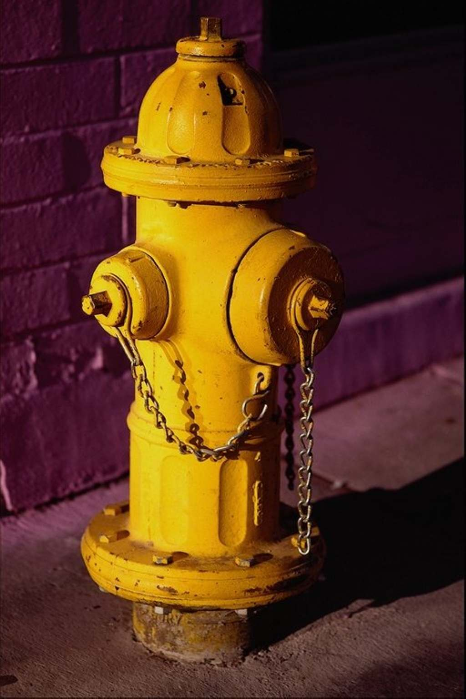

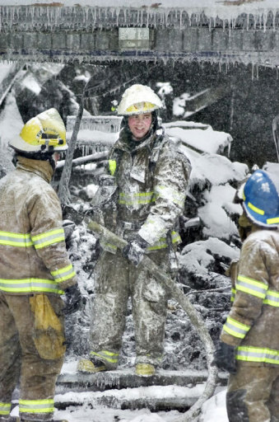
Keep Warm

Look Outs
This is your newsletter let us know what you want to see in it or just drop a line to let us know what you think. Send your emails to Jay Diemert at ftf@firefighting.net.
You can also check us out at our website www.fanningtheflames.synthasite.com. We are posting your tattoo, motorcycle and patch pictures at the site.







Heart Attack Potatoes (HAPs)
- 5 pounds of potatoes
- 1 large tub of sour cream
- 1 brick of cream cheese
- 1/2 to 1 stick of real butter
- Paprika Black Pepper Lawry's Seasoned Salt
- Peel and boil the taters, just like you were making mashed taters.
- When they have reached the desired softness, drain the water, mix in the sour cream, cream cheese, and 1/4 to 1/2 the stick of butter, along with some salt and pepper.
- Mash or whip the mixture.
- Place the mixture in a 9 x 13 pan, cover with foil, and bake in the oven for 45 minutes.
- Take out the taters after 45 minutes, and rub the rest of the butter over the top, spreading it evenly until it melts.
- Add some Lawry's and Paprika for a little color, and then place back in the oven, uncovered, for another 15 minutes or so. Careful! They're piping hot!!!
- Serves 8 firefighters.
- You can use some leftover juice from the loaf to make gravy.
Recipe by Firefighter: Tim Linke - Local 644 Lincoln, NE

